Project Design Phase
User Interface (UI) and Experience Design
Date | 25 October 2025
Team ID | NM2025TMID02695
Project Name | Garage Management system
Maximum Mark | 2 Marks

4.3 User Interface (UI) and Experience Design
The GMS includes a custom Lightning App to streamline navigation and provide role-based visibility.
4.3.1 Lightning App Configuration
- App Name: Garage Management Application
- App Items (Tabs):
  - Customer Details
  - Appointments
  - Service Records
  - Billing Details
  - Reports & Dashboards
- Branding:
  - App Logo: Custom garage icon
  - Primary Color Theme: Blue-gray for professional appearance
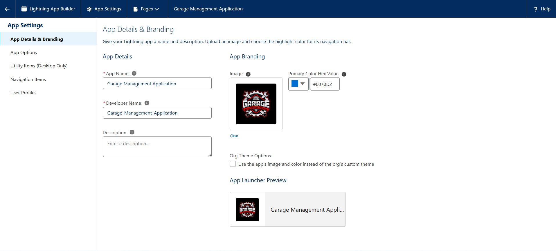
4.3.2 Page Layouts and Record Types
Object | Page Layout Features | Visible To
Customer Details | Basic info (Phone, Email, Name) | All Users
Appointment | Vehicle number, date, linked customer | Sales Person
Service Records | Quality check status, Service status | Sales Person / Manager
Billing Details | Payment status, service rating | Manager only
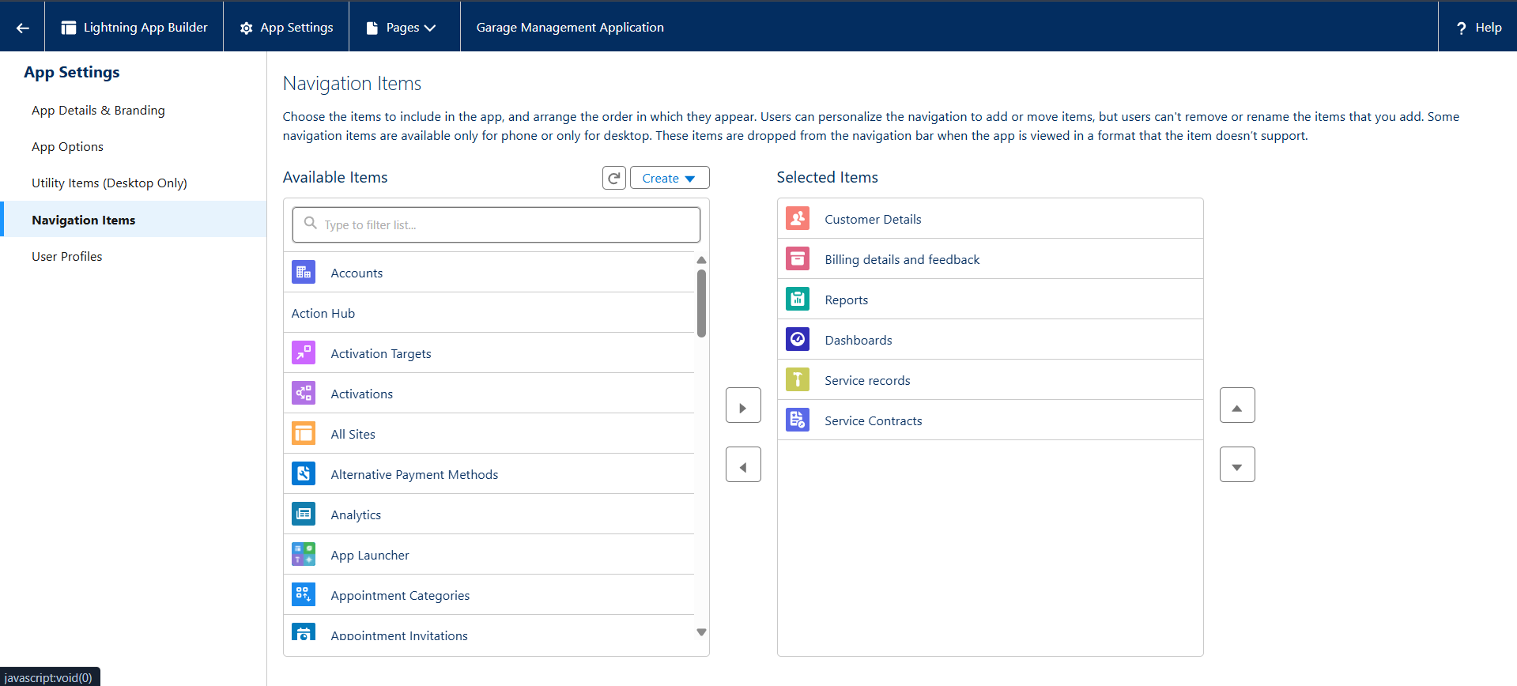

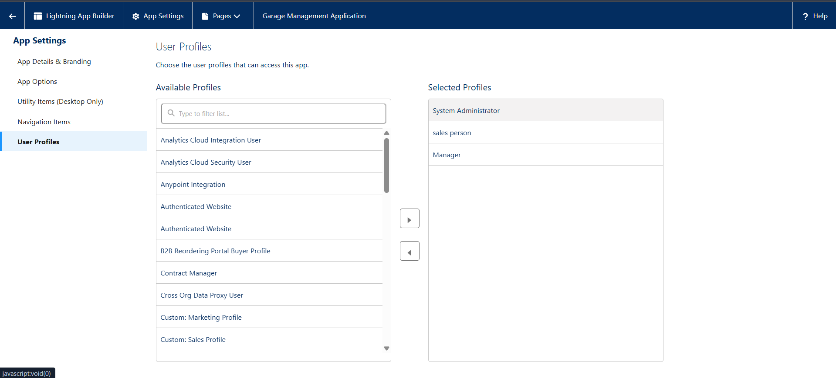
4.3.3 User Experience Enhancements
- Dynamic Forms: Used for conditional visibility (e.g., show “Service Amount” only when status = Completed).
- Quick Actions: “Create Appointment” and “Add Billing” for faster navigation.
- Compact Layouts: Optimized for mobile and tablet Salesforce views.
4.4 Conclusion
The Project Design Phase establishes the detailed Salesforce configuration blueprint for the Garage Management System (GMS). Through an efficient data model, robust automation, and a secure UI design, the system ensures seamless service tracking, reliable billing, and data integrity. This design serves as the foundation for the upcoming Development and Testing Phase.

